* Azure is Microsoft public cloud.
* 2nd large Cloud service
* Update year by year
* Major clients



**Regions** –

* Microsoft build a lot of datacenters fro Azure
* Each data center’s locations called Region
* 60 Regions (more than any other cloud)

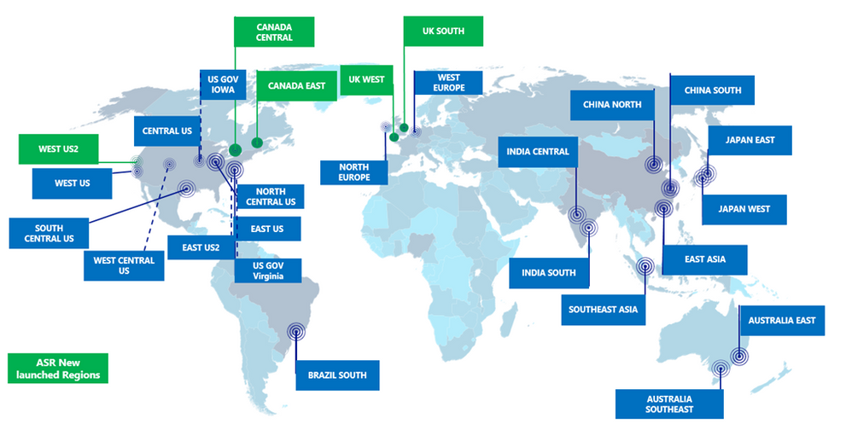

**Zone** –

* Some of regions have more than one physical data center
* Great for availability in case one datacenter fails
* Each data center is called Zone

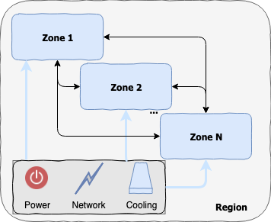

* When there is more than one data center in a region, the region is said to have an Availability Zone.
* Some cloud service benefit from Availability zone. They have availability to skiping one zone to another.

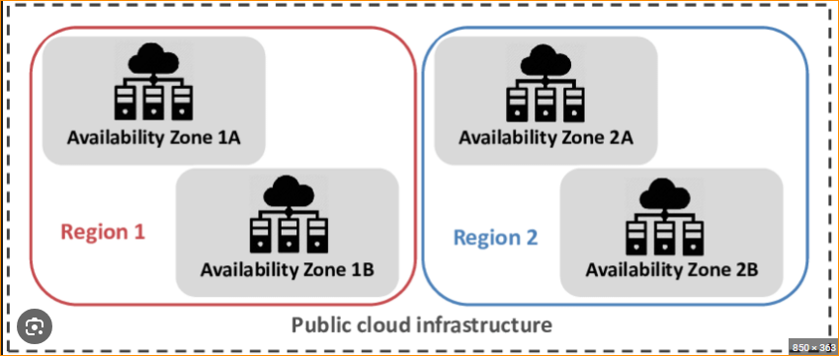

Azure regions and zones –

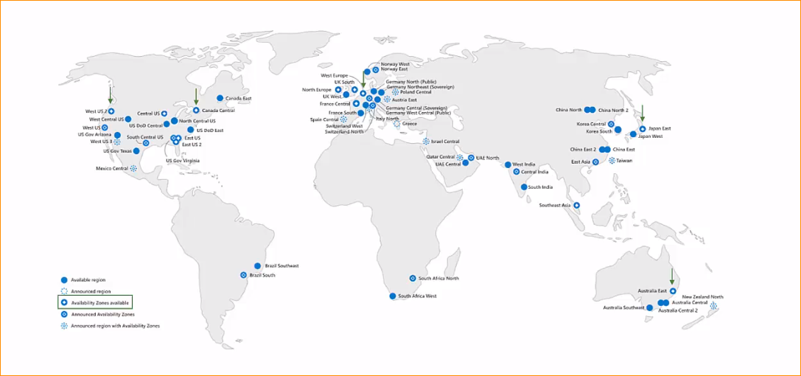

**Paired Regions –**

* Some regions have designated pair region
* For increased availability
* When a full region fails – the other one can fill its place
* Relevant fro some of the cloud services
* Pairs are set by Azure and cannot be changed
* Pairs are set by Azure and con not be changed

Example – Central Us and East Up are two pairs

And North Europe and west Europe are pairs.

And Central india and South india are pairs.

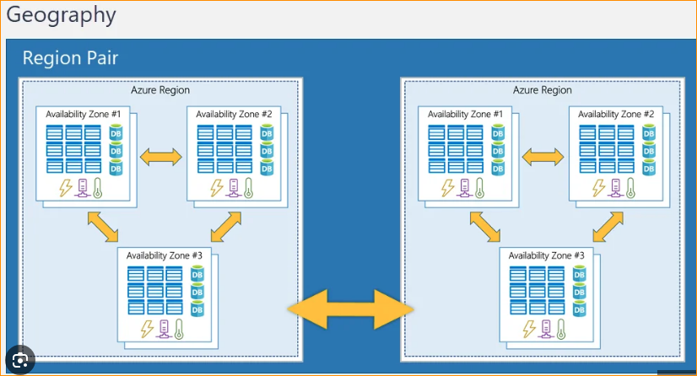

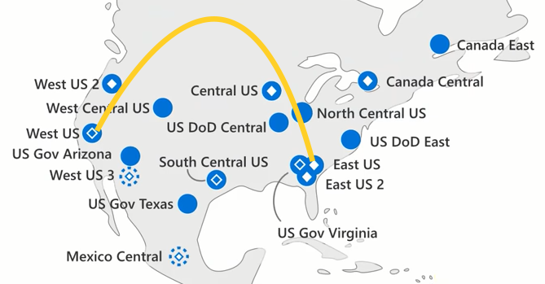

**Azure Services –**

* Everything that can be done in the cloud is called **cloud service**
* Example – Creating virtual Machines, building databases, setup networks use AI algorithms, using central user management etc. those are cloud services.

**Ex- Azure Services-**

<https://azure.microsoft.com/en-us/products>

